**Step 1 : Creating a storage account**

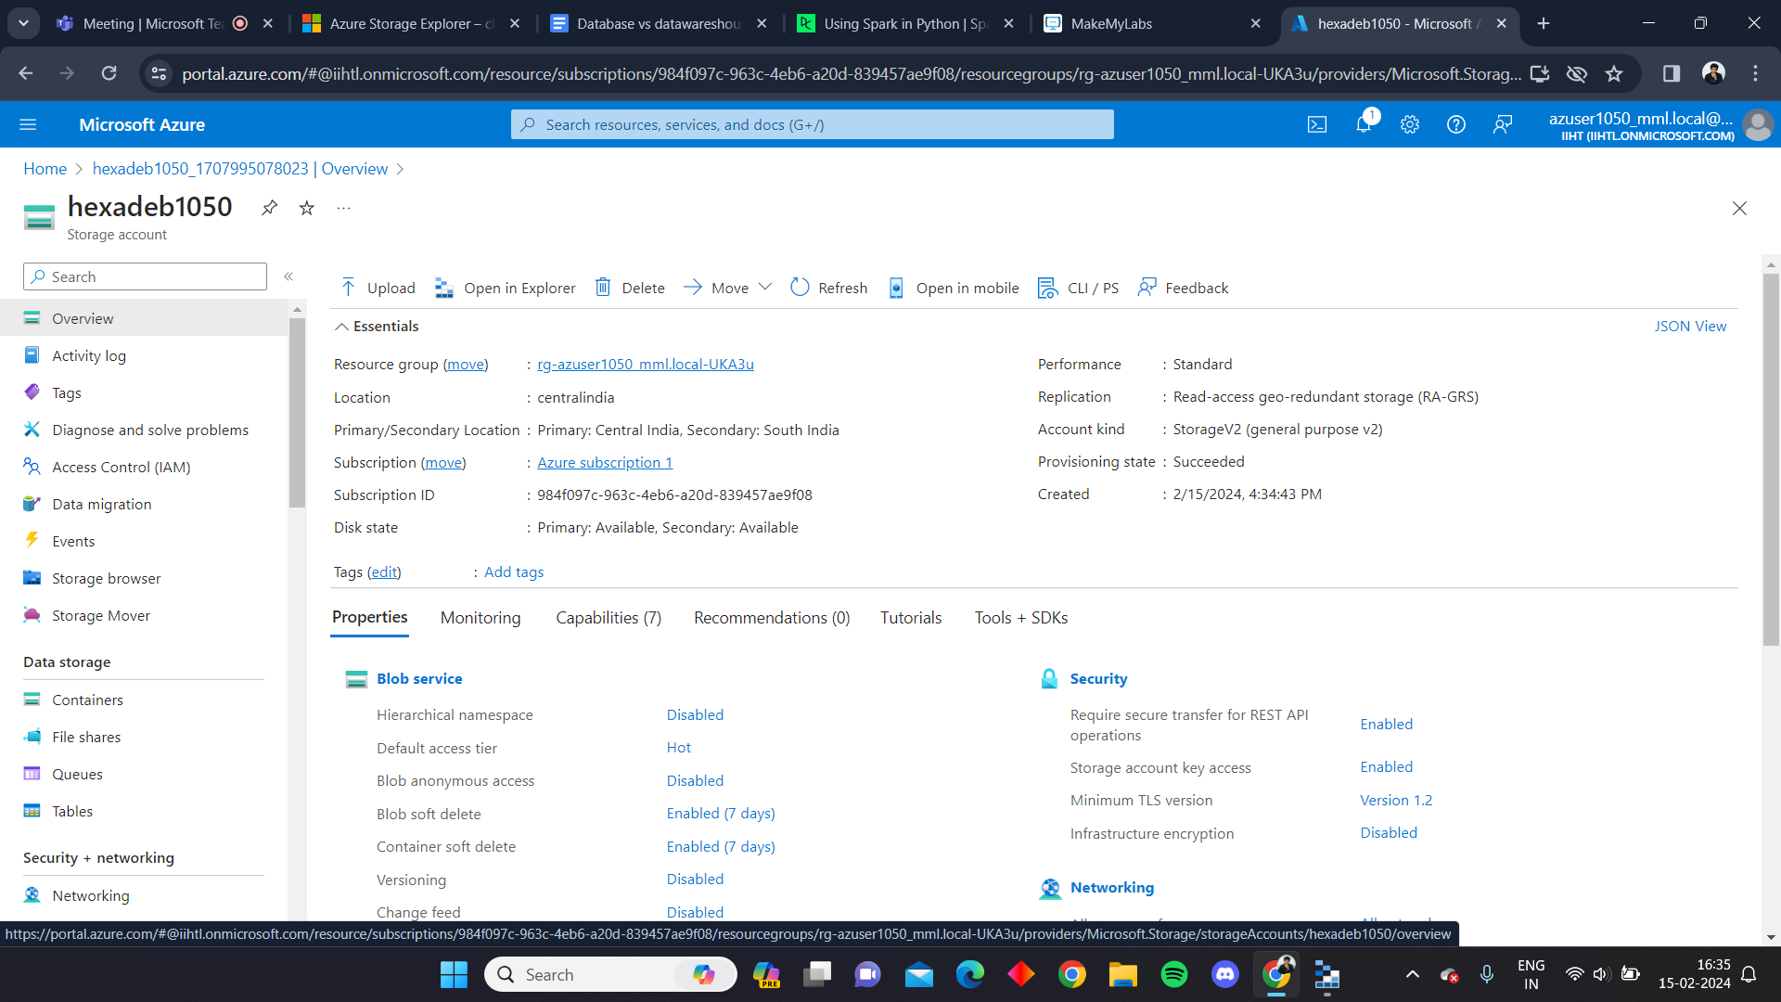

**Step 2 : Generate SAS and connection string**

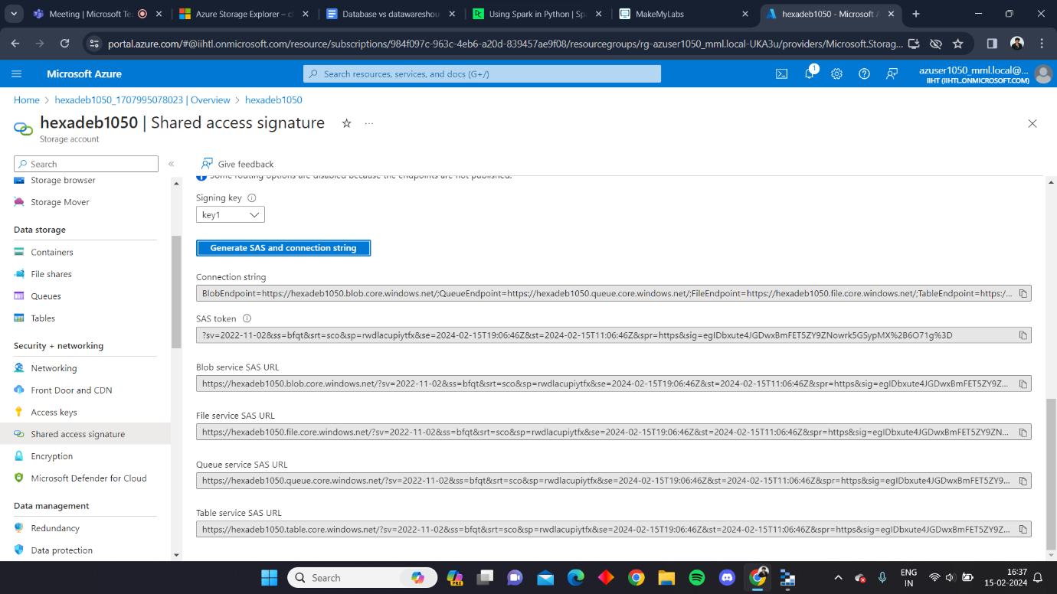

**Step 3 : Connect the azure resources to the Microsoft azure storage explorer**

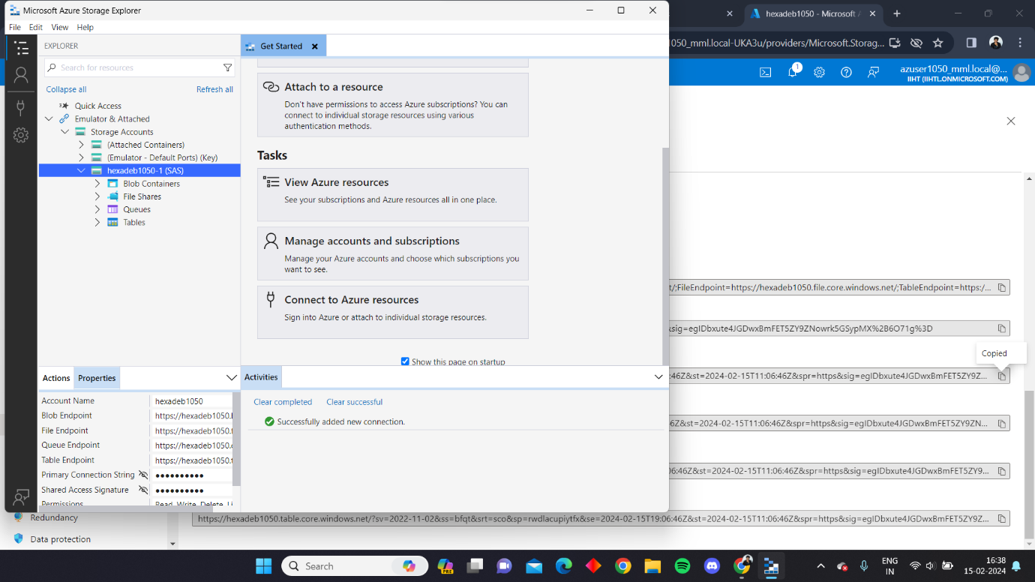

**Step 4 : Create a container in the storage account**

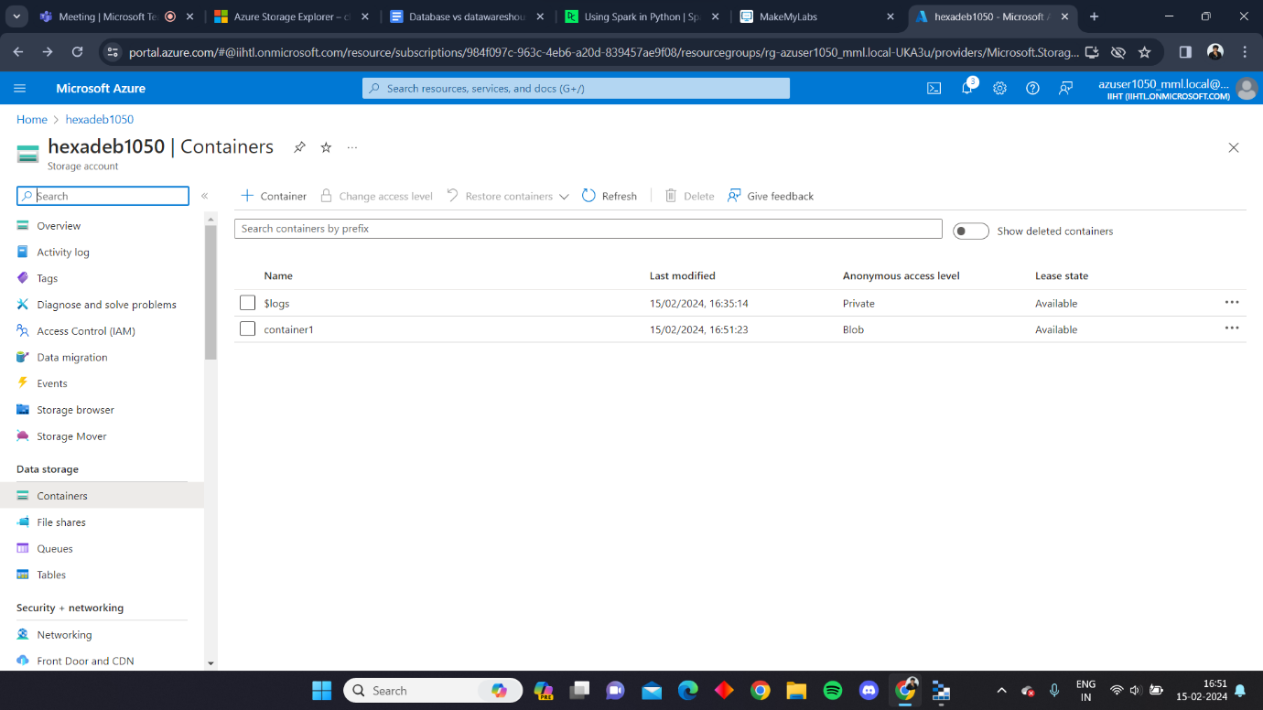

**Step 5 : Access the container location through the explorer.**

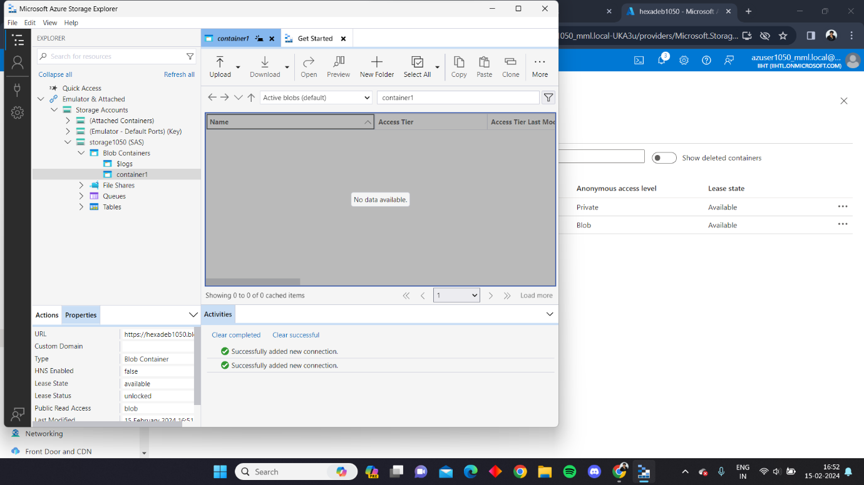

**Step 6 : Upload a file from the local using the explorer**

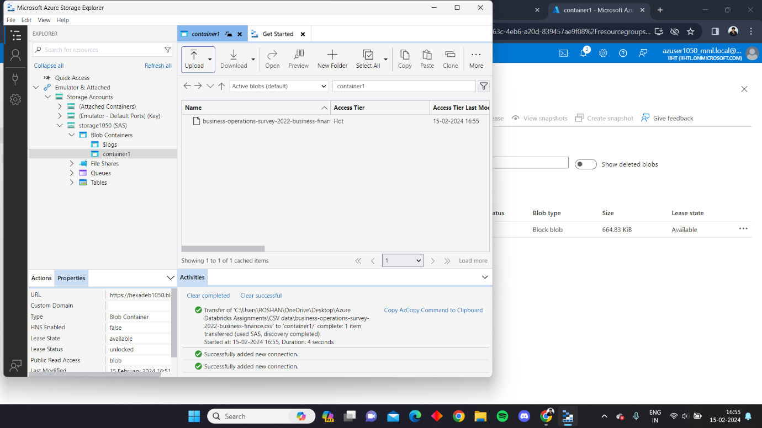

**The files will be reflected in the container present in the storage account.**

